# CS 255 System Design Document

Parker Harb

## UML Diagrams

### UML Use Case Diagram

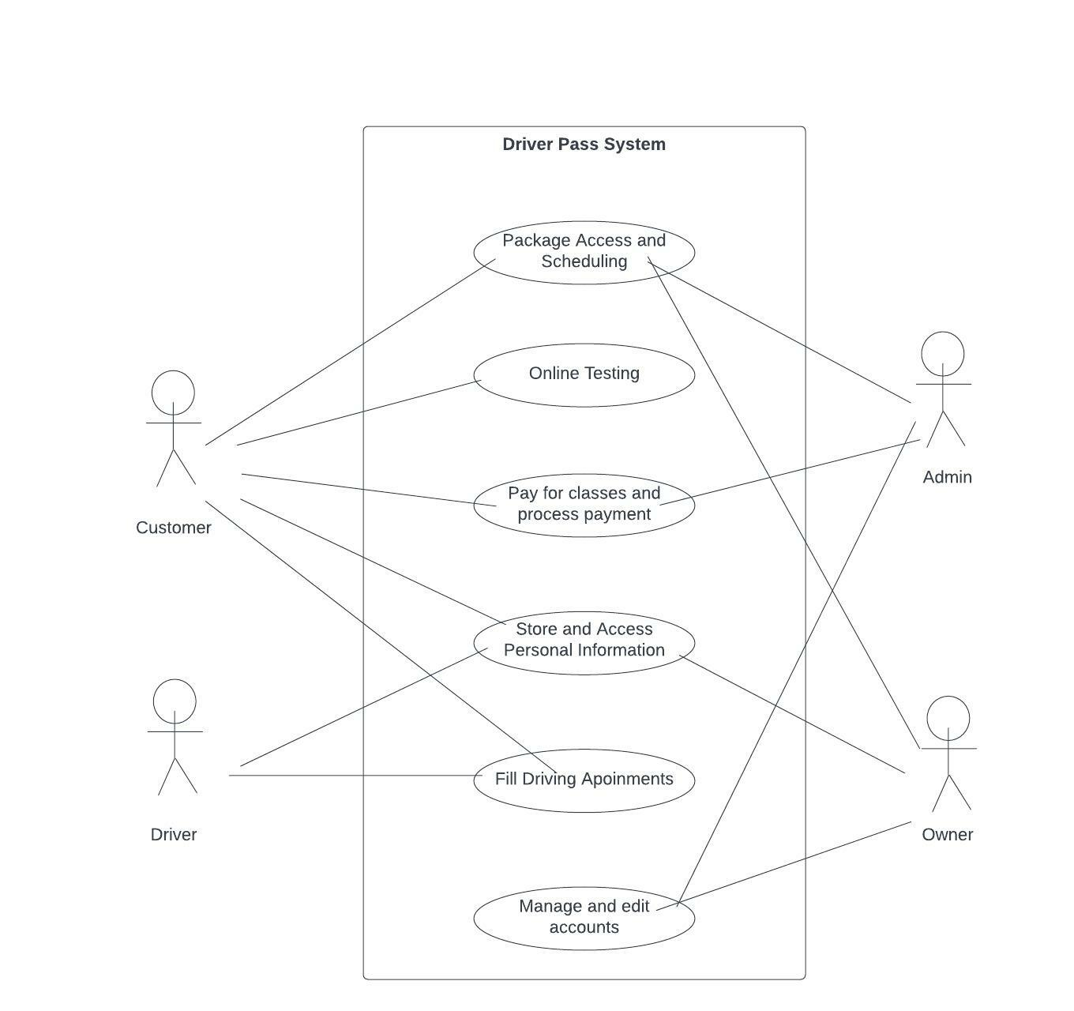

### UML Activity Diagrams

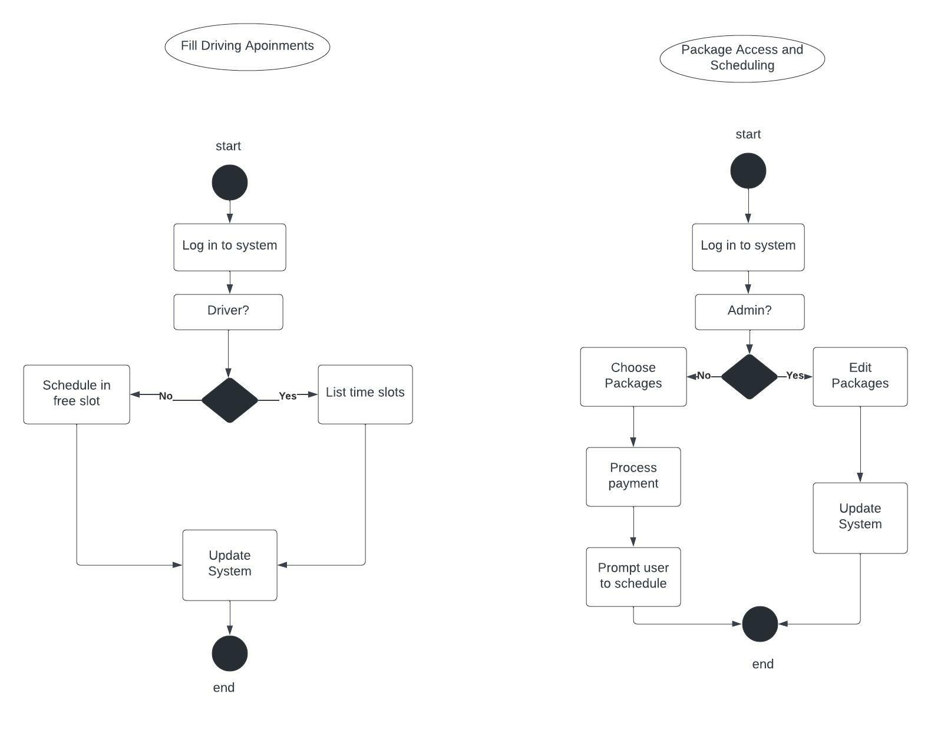

### UML Sequence Diagram

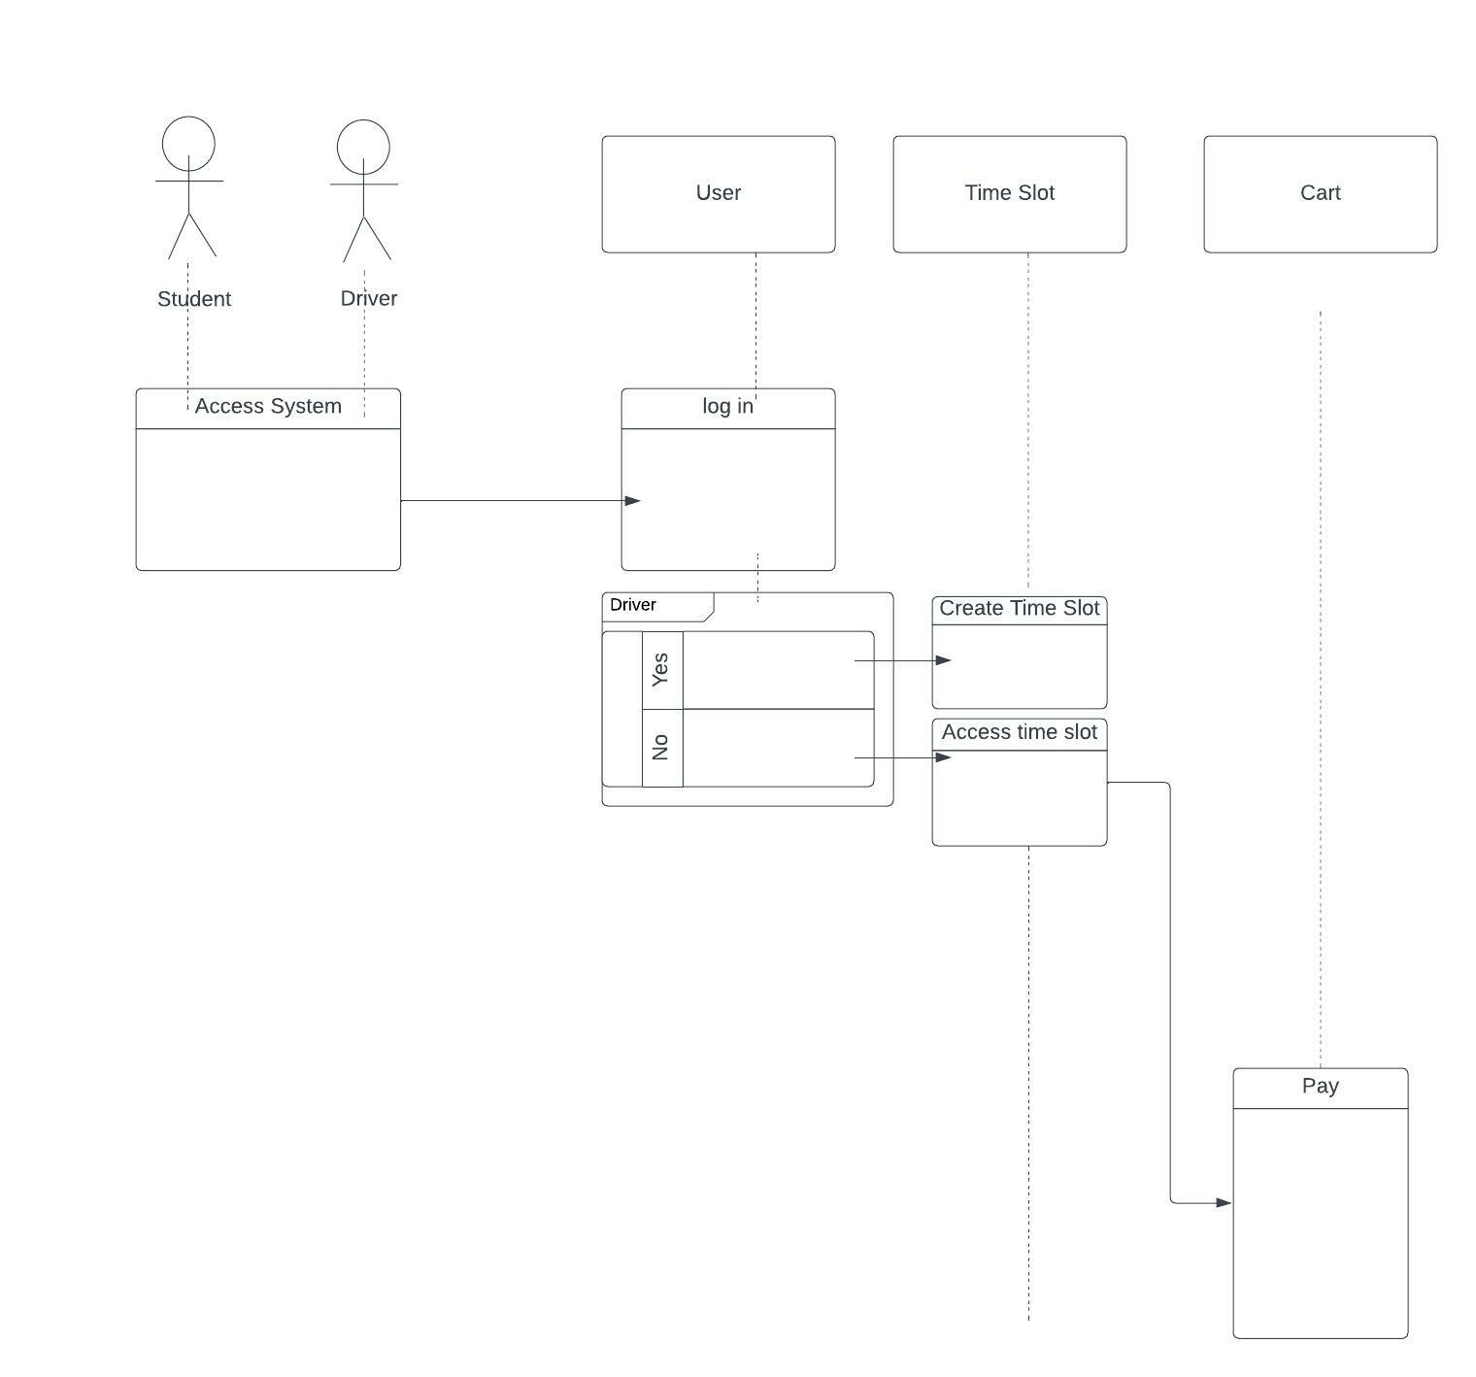

### UML Class Diagram

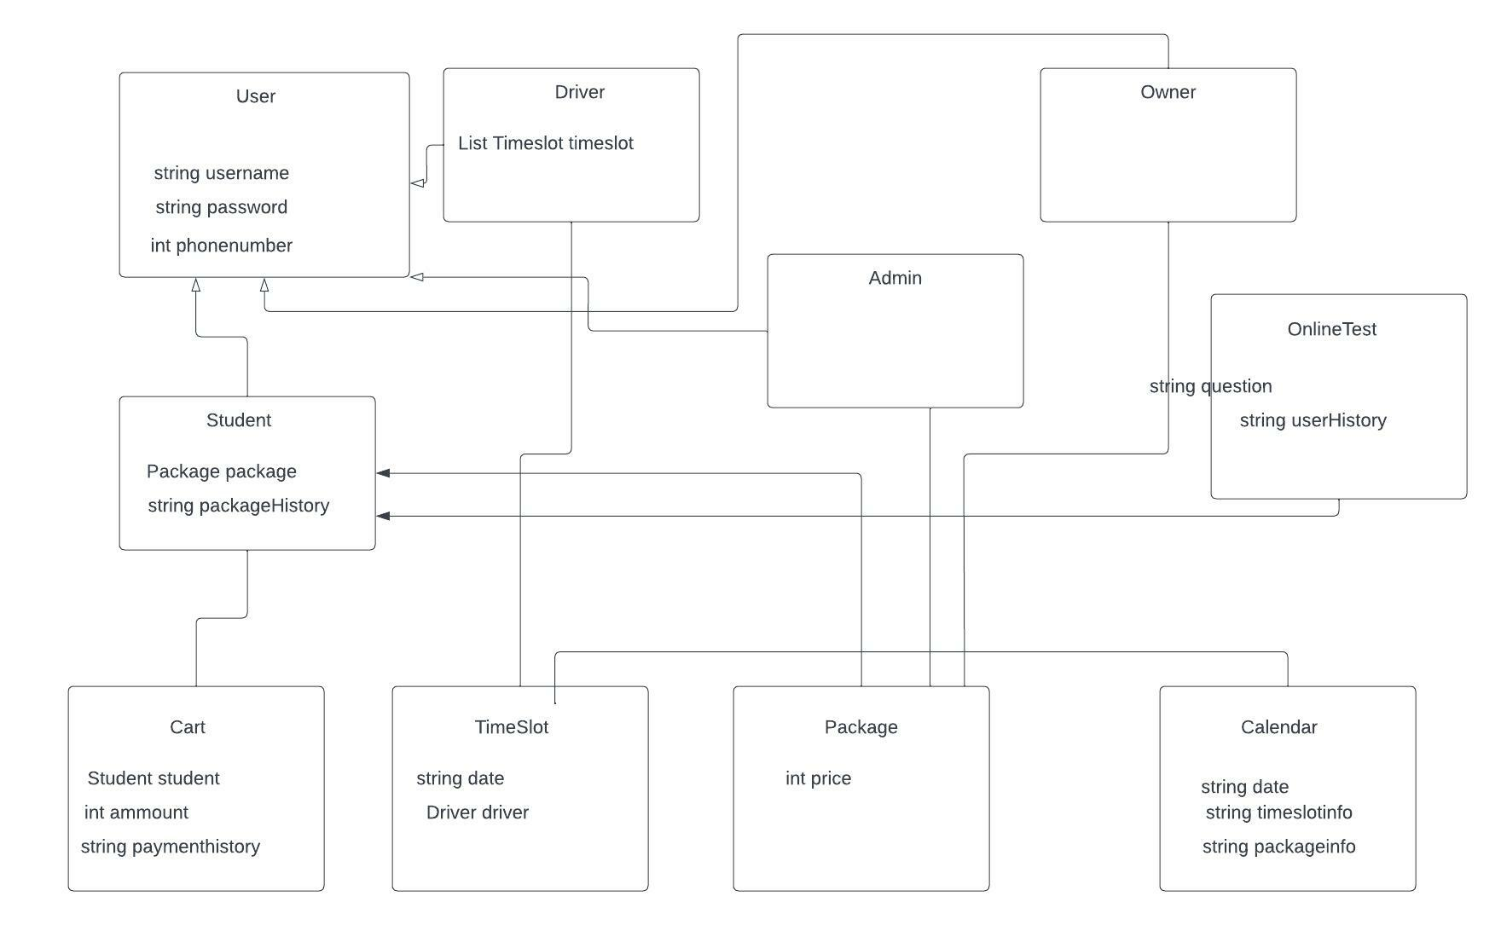

## Technical Requirements

1. Hardware Requirements:
   1. There will need to be a cloud based server system in place to hold all the data.
   2. The Admin will need a computer they can use to access and debug this server
   3. Any users will need some kind of device to interact with this system
   4. The server should run a linux environment, while the front end should work well across systems
2. Software Requirements:
   1. Linux will be run on the backend.
   2. The front end will be a web app, written in HTML5, CSS3, and Javascript.
   3. There will need to be a relational database, recommending mySQL.
   4. The system will need to be scalable, reliable, and the user interface needs to be attractive.
3. Tools:
   1. There need to be various software for project management.
   2. There is a need for a system to manage the database.
   3. There is a need for a tool that will allow access to packages without programming
   4. A tool to change online tests is a need to have.
4. Infrastructure
   1. IaaS system should provide necessary cloud system infrastructure.
   2. Front end will run on users own machines.